**PRESS RELEASE**

**COMMUNICATIONS AND MEDIA TEAM OF THE 2023 ASEAN SUMMIT**

**No.27/SP/TKM-ASEAN2023/ENG/5/2023**

**Indonesia Ensures Results of 42nd ASEAN Summit 2023 Concrete and Useful**

**Jakarta, 5 May 2023 -** Indonesia ensured that the three main pillars of its chairmanship in ASEAN 2023 will produce concrete results and can be implemented by every Member State in the long term. Indonesia encourages ASEAN to continue to be the motor of stability and peace in the region and the world.

This was stated by Minister of Foreign Affairs Retno L. P. Marsudi during a Press Briefing on Online Scams, Sudanese Evacuation, and the 42nd ASEAN Summit 2023 in Jakarta, Friday, 5 May.

"Indonesia's chairmanship in ASEAN will be used to lay a strong foundation for the long-term vision of ASEAN post-2025. It’s important to do to prepare ASEAN to face long-term challenges. This is where it’is necessary to strengthen capacity and institutions so that ASEAN becomes more agile," said Retno.

There are three main pillars in the Indonesian chairmanship theme “ASEAN Matters: Epicentrum of Growth. The first pillar is ASEAN Matters, it is how Indonesia will lead Member States to make ASEAN resilient to face various challenges and to become the motor for maintaining world stability and peace.

"This is where ASEAN needs to put a long-term vision and strengthen its capacity and institutions," said the Indonesia’s Minister of Foreign Affairs.

Furthermore, on the second pillar of the Epicentrum of Growth, Indonesia will maintain and strengthen concrete cooperation of Member States so that the regional community will benefit from it.

"So, we hope that Southeast Asia can continue to be the center of economic growth, and more importantly will be able to deal with external shocks," said Retno.

The third pillar is related to the Implementation of the ASEAN Outlook on the Indo-Pacific (AOIP). Retno emphasized that ASEAN's approach is consistent, we want to build concrete and open cooperation with all countries to make the Indo Pacific a peaceful and prosperous region.

"This is very important given the growing rivalry in the Indo-Pacific region," said Retno.

She also said that Indonesia has always maintained real cooperation in ASEAN, such as in the sectors of education, energy, financial stability, to combating trafficking in persons.

"This is important for us to establish so that the benefits can be felt for the people of ASEAN and to support Southeast Asia as the epicentrum of growth," she said.

On this occasion, Minister of Foreign Affairs Retno L. P. Marsudi also emphasized that various cooperation negotiations and ASEAN institutional strengthening carried out by Indonesia under its chairmanship had gone through a long and focused process.

"So, if you think og the summit (9—11 May), it does’nt mean that negotiations will only start on 8. The negotiations have been carried out in a long time," she said.

Indonesia has carried out negotiations on a number of possible deliverables, including the Chair Statement, 2045 Vision, strengthening ASEAN capacity, full membership of Timor-Leste, combating trafficking in persons, and protecting migrant workers as well as related to the protection of fishery workers, the health sector, the formation of village networks, electric vehicle ecosystems, and payment connectivity in the region.

"The negotiations are continuing, especially regarding documents that will be produced at the 42nd Summit. This negotiation will continue until the unilateral meeting, the SOM meeting and even up to the Foreign Ministers’ meeting for unresolved issues," said the Foreign Minister. (Infopublic/TR/Elvira/UG/PPR)

***

For more information, please contact:

**Director General of Public Information and Communications of the Ministry of Communications and Informatics – Usman Kansong (0816785320).**

Get more information at <http://asean2023.id>, <https://infopublik.id/kategori/asean-2023>, and <https://indonesia.go.id/kategori/ragam-asean-2023>

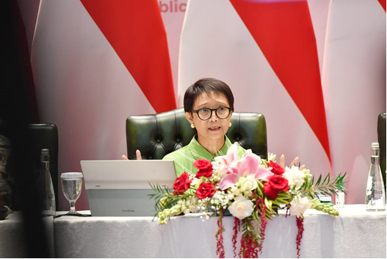

Minister of Foreign Affairs Retno Masudi during a Press Briefing in Jakarta, Friday, 5 May 2023. Indonesia ensures that the three main pillars of its chairmanship in ASEAN 2023 will produce concrete results and can be implemented by every Member State in the long term. Photo: Amiri Yandi/Infopublik